INSTRUCTIONS FOR 2018-2019
PROPOSAL WRITING

Please don’t hesitate to call Stephen McB, Will or Adriana if you have any questions!

Gather necessary materials. You will need:

- Master excel spreadsheet entitled "2018-2019 Proposals-Master Spreadsheet". This master is based on 2017-2018 Cycle 3 approvals (the SCWI provincial starting point). There are four tabs:
- Master sorted by Project. (This is the spreadsheet we will be working from on Dec 5 and 7)
- Master dual credits sorted by Boards
- Master dual credits sorted by Colleges
- Simple chart showing the starting point for seats and funding

You will need to work from your own spreadsheet section.

- Accurate up-to-date transportation costs for college faculty mileage (return kms to the secondary school) and board bus costs (secondary school to the college).

- Dual credit project descriptions. School board reps will need to do some work with this. Colleges only worked on this last year. These program descriptions are due to Adriana by Monday December 4.

- Activities and Forums: Colleges especially to review these descriptions. The second tab on the master spreadsheet contains these descriptions.

- If you are requesting miscellaneous funds, you will need (preferably) a per-seat amount and a rationale for the request.

- SCWI resource materials:
- RFP-CODE letter
- RFP Requirements
- Dual Credit and ADC Rubrics
- Dual Credit and Forums/Activities Benchmarks
- OYAP Seat Purchase Agreement forms

- Data by project and by board

USE OF DATA: Notes from Smart Goals Meeting with Sonja and Phil on November 2 2017
- Overall they are pleased with our results.
- Certain programs will not be automatically re-approved; we must look at our data and provide very strong rationales if we wish to re-submit dual credits with poor data results. (This message was repeated a number of times.) We should be at least within 10% of the provincial average.
- Be careful about over-filling dual credits.
- A committee of 6-8 people review the proposals so very little gets missed.
- The committee looks at historical data – not just the previous year’s data.
- Be innovative
- Be mindful of the number of SHSM dual credits we have. We have many of them and the target group is not always captured. Are we getting the dollar value out of a SHSM dual credit with 20 approved seats where only 20% of the students are actually SHSM?
- We are encouraged to fill our SWAC sections as they are costly to deliver
- Look at the discrepancy between the OSS and College success rates and address this in the rationales
- We may wish to question 2 sections of the same dual credit within one school
- Dual credits should have at least 75% of the students in the target group
- Re-evaluate summer school
Sonja and Phil’s email follow-up to our meeting:
Greetings RPT 6,
Wish we could have met with all of you regarding your SMART goal report, but while you’re enjoying turkey we’ll be enjoying reviewing your 2018-21 proposals.
Just to highlight a few things:
- The results are excellent. As a result, programs with results below the provincial average really stand out – these results cause us pause to question whether this is a good program to reapprove.
- In section 3e, please note anywhere the approved vs actual, retention, OSS success, and/or college course success are significantly below the provincial averages. Should you wish to reapply for these programs, please provide a explanation and any more recent data (2017-18) to help us understand why this would be a worthwhile program to reapprove.
- In section 4d, please review programs where the percentage of participants in the group for whom the program was designed was quite low. Should the target group be changed? Should the program continue? Should a new program take its place?
- Overall the percentage of SHSM students in SHSM programs was low at 65%. This might be worth discussing with the schools that have SHSM programs.
Don’t hesitate to get in touch with us if you have questions regarding your SMART goal report. If you have questions on the RFP, please contact David Armstrong.

Phil and Sonja

Notes:
- All college presidents and board directors received the CODE memo and the Request for Proposals.

- In light of the data notes above, Board reps will need to do some work on the rationales for their projects. This will need to be done well in advance of December 7 (deadline to me).

- Come prepared to the meetings on Dec 5 and 7 with all details required in each of the spreadsheet cells.

- Focus continues to be on primary target group and SWAC.

- Night school and e-learning will not be approved – unless you have these programs grand-fathered in your RPT

- No new money for SHSM dual credits. Use your existing seats and re-shuffle as needed.

- College and board benchmarks remain the same. Use miscellaneous requests if benchmark is not sufficient.

- Ideas/proposals for forums and activities regarding mental health are welcomed.

- If transportation was not claimed last year, no new transportation money will be approved.

- If making changes electronically, the bottom line (highlighted) should automatically keep a total of your changes (unless you erase the embedded formulas). The 4’th tab on the master will show your original totals (ie: what you should try to stick to.)

- Changes to courses will not affect the Board benchmark but may impact the college benchmark. For example, moving from a non-tech to a tech course will not affect the board benchmark but will increase the overall cost of the dual credit on the college end (example: higher benchmark, addition of miscellaneous costs…)

- Changing schools may also affect travel/transportation costs.

- VERIFY your transportation costs. This is the area that we always end up giving back at the end of the year. Most bus companies should be able to give you a ball park figure of transportation costs to the various colleges for the one day trip or for college-delivered models.

- Colleges will need to know faculty transportation kms (return) to the various schools. Mileage for proposals is always calculated at .40 cents/km.

- Each cell represents a piece of information that needs to be entered into EDCS so knowing as much detail as possible is necessary.

- Check the data. If the project data is under the provincial average please provide a rationale for continuing with the dual credit. We will need to use as much information as possible to write a creative rationale taking into account the variety of schools involved in each project.

- Share anecdotes of success stories to help with poor data results. (Ex, Project 646-PR is a dual credits for new parents. While the data is low on all 3 counts, the target group is the most vulnerable and at-risk student. Share one success story if you can.)

- For tech and culinary dual credits with all 3 colleges, they have to be double period classes – unless they are already running as a single period and have been grand-fathered. Durham College will look at a case-by case basis for single periods.

- If you are adding dual credits, try to fit them into existing projects.

- If it is a BRAND NEW PROJECT idea, you will need to provide a lot more information. We can work on this together if the college has approved the idea.

- OYAP coordinators: You have been provided with all of the information that you need to have ready by December 5. If you’d like to meet to input this project into EDCS with Stephen, Will and Adriana, please arrange to meet with us before that date. Don’t forget the signed Seat Purchase documents.

- While everyone is welcome to be present all day on the two proposal writing days, we will focus on one Board partner at a time as per the schedule below. Please let us know your intentions for organizational purposes (refreshments, space, lunch…). RSVP to Will or Robert/Sue so they can plan accordingly.

TUESDAY, December 5  @FLEMING COLLEGE  (FLEMING AND LOYALIST DUAL CREDITS)  ROOM: B3347  PARKING: Elm Lot- Code #15154540 (See below for more details.) |  | THURSDAY, December 7  @DURHAM COLLEGE  (DURHAM DUAL CREDITS)  ROOM: SSB-113B– Oshawa Campus, Student Services building  PARKING: Founders 2 parking lot
9:30am | PVNC | 9:30am | DCDSB
10:30 | TLD | 10:30 | DDSB
11:30 | LUNCH | 12:15 | LUNCH
12:15 | DDSB/DCDSB  Stephen H to arrange with Fleming and Loyalist beforehand | 1:00 | PVNC
1:30 | KPR | 1:30 | KPR

ALL PROPOSAL DETAILS ARE DUE AT THE END OF THE DAY FRIDAY, DECEMBER 8, 2017 AFTER WHICH THEY WILL BE INPUTTED INTO EDCS.

Monday December 4 2017 | Project descriptions due to Adriana by the end of the day
Tuesday, December 5 2017 | Fleming College proposal writing (Fleming and Loyalist dual credits)
Thursday, December 7 2017 | Durham College proposal writing
Friday, December 8 2017 | All proposals due by the end of the day
Friday, December 15 2017 | Due in EDCS for sign-off by 1:00pm

Guest Parking Instructions
Sutherland Campus

Parking Services would like to welcome you to Fleming College and hope that we can make your arrival on campus as welcoming and seamless as possible.

As an invited guest you are being provided with complimentary parking. Please follow these instructions when you arrive on campus:

- You may park in ELM Lot (please park in the same row as the Pay and Display Machine)

- Go to the Pay & Display Machine located in the lot.

- Press the “Code” Button.

- Enter the following code 15154540

- Press the Green Button with the check mark.

- The code will take a moment to process (watch the screen for confirmation)

- Press the “Prepaid” button once the code is processed to print a payment receipt.

- Display the payment receipt on your dash with the date, time and amount visible.

- If you need assistance in locating a department or meeting room the Information Booth is located inside the main entrance or you can contact them from any campus phone at extension 8000.

Please remember that all students, employees and visitors to campus are required to abide by the College Parking Regulations and to obey posted signage.

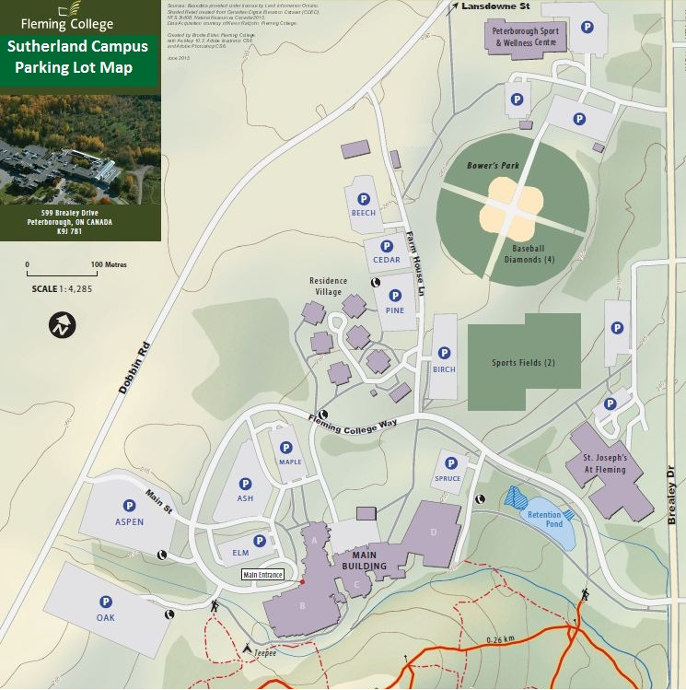

Parking Lot Information:
Ash Lot: General Permits Only
Aspen Lot: General Permit and Pay & Display
Beech Lot: Economy Permits Only
Birch Lot: General Permit and Pay & Display (Sports Field Users no charge after 5pm)
Cedar Lot: Residence Permits Only
Elm Lot: Pay & Display Only (Visitors)
Maple Lot: Premium Permits Only
Oak Lot: General Permit and Pay & Display
Pine Lot: General Permit and Pay & Display (Sports Fields overflow – payment required)
Spruce Lot: Pay & Display Only (Visitors)

